

*java iot developer*

aSsignment -1

**SUBMITTED BY: SUBMITTED TO:**

**AYUSH KUMAR JHA Chandan Sharma Sir**

**SAP ID - 500086400**

**Enrollment no - R200220083**

**B.C.A -I.O.T.**

Q1. Given a person class, the way in which we instantiate the person class is similar to the way in which we instantiate the Array list. As shown above what can be observed with respect to of Array Lists.

Ans 1.) Instantiating a normal person class

Person P = new Person ( ) ;

Here we creating the object "P" and are then creating the memory through new Keyword. Moreover, here we have not declared the type of object we have created

Instantiating a Array list:

ArrayList<string> list=new Array list <sting> ();

Here we are creating the object "list" and then providing it memory allocation: But while Creating we are specifying the type i.e., string in angular braces If we try to add another type of object, it gives compile time error.

The way we instantiate the person class the same way we instantiate the array list means, the Array Lists are a default constructor of the ArrayList class

Q2. What parallels can you observe between Person class & Array List.

The new operator in both instantiation invokes the public constructor(with some function) of the particular class. It instantiates the classes by allocating memory for a new object.

Q3. What is an Array List? Provide Examples.

Ans An ArrayList is a special type of list that allows you to create resizable arrays. The ArrayList class implements the List interface, which is used to store ordered data. It is found in the java.util package. A Java ArrayList class uses a dynamic array for storing the elements. The ArrayList in Java can have the duplicate elements also. It implements the List interface so we can use all the methods of List interface here. The ArrayList maintains the insertion order internally. It inherits the AbstractList class and implements List interface.

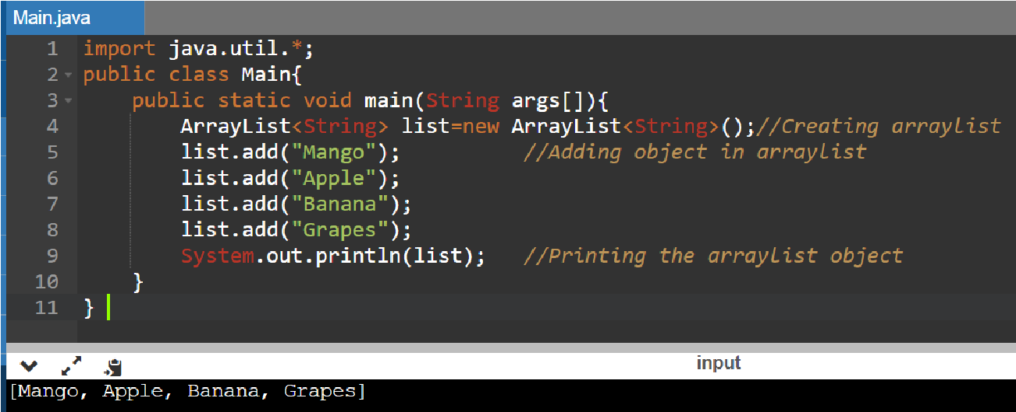

Q4. What are the similarities between Array & Array List? Provide Examples.

Ans) Similarities between Array and Arraylist: Array and Arraylist both are used for storing elements Array and Arraylist both can store null values. They can have duplicate values.

Both are unordered lists. If we change the order of elements in both array and Arraylist it is valid.

Only the index of that value will be changed.

Both use the index to refer to their elements. We can access the elements of both Array and ArrayList using an index of that element. In the given Array list if we want to access element 78, we can access that using index 2. Same for the array if we want to access element 26, we can access that using index 2.

Both array and ArrayList can have duplicate elements in them. It means if we have an ArrayList Alist = {15,14,78,14,15} and an Array Arr = {78,89,26,89,45} it is totally valid in arrays and array list.

Both supports null values. Both Arraylist and Array support null values as element.

import java.util. Arraylist;

import java.util. Arrays;

Class Aarr{

public static void main (shing args[]) {

int[ ]arr=new int[3];

arr[0]=10;

arr [1] = 20;

arr [2] =30;

Arraylist<Integer> dis =new Arraylist<Integer>(); list.add(10); list.add(20); list.add(30); system.out.println(list); system.out.println(Arrays.toString(arr));

output:

[10,20,30]

[10,20,30]